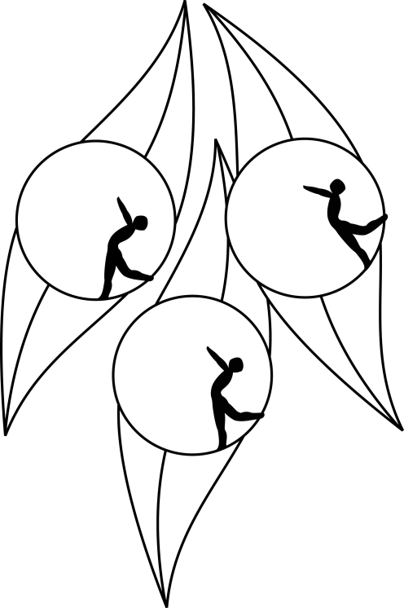
SOUTH AUSTRALIAN ICE SKATING ASSOCIATION Inc.

RESULTS

TEST SESSION

7 May 2009
Ice Arena, Thebarton

Congratulations to the following skaters:

Junior:
Jessinta Martin
Elementary 2:
Ashley Colliver
Elementary 1 Technical:
Amelia Davis
Elementary 1 Figure Pattern:
Madeline Swan
Preliminary:
Scott Broadbridge

